10 Design
I know design, like art, is entirely subjective. An interface for my application that one person might trumpet as the best thing since sliced bread might have another's teeth on edge. I hope I have designed an interface that is not too intrusive and contains sufficient user feedback to enable intuitive use of the application.
I deigned the logo based on the Dublin crest with its 3 castles, not dissimilar to the millennium logo in use on everything from milk bottles to our commemorative coins for the 1988 celebrations. The isometric coffee cup is a nod to my former career and the burnt orange colour is my choice to offset the grey used throughout the rest of the site.
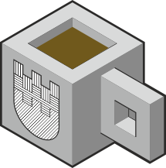

Fig 10.1
The map tiles I baked in Tilemill use the same colour scheme, albeit more washed out and hopefully do not detract from the main function of the application.
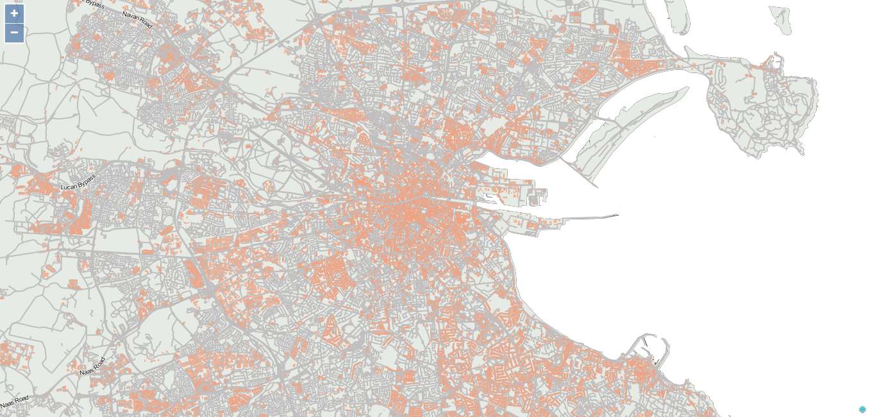
Fig 10.2

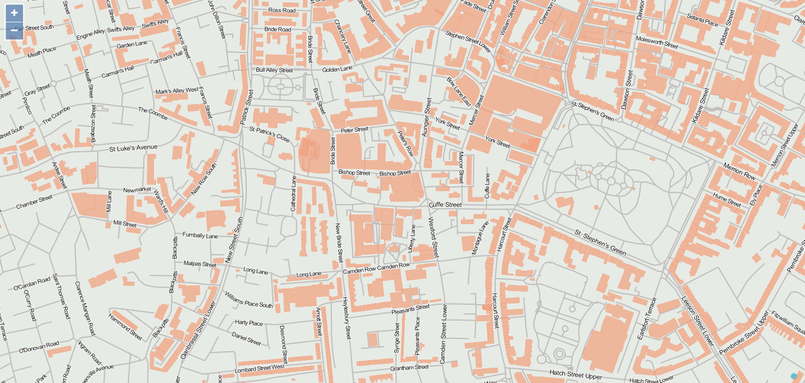
Fig 10.3
The whole world of cartography is a science unto itself and considering this was not a cartography project, I felt the light touch I gave it was sufficient. I would like to get more in depth with the process of preparing the maps but was very conscious of the time I would find myself sinking into it for minimal return. I had prepared a number of animated svg images animated using css only for use on the site, but my ambition and artistic leaning had to be curbed as I was struggling to find somewhere to use them. I did host a “holding page” on the domain which was svg animated using css, however once the site started to come together I had no longer any use for it.
For each shop I designed a custom marker pin, based on their logo / brand. I believe this allows a browser, familiar with the shops in question to zoom directly into their desired location without having to pan around the map clicking on generic marker pins in order to find the shop they desire.
 | 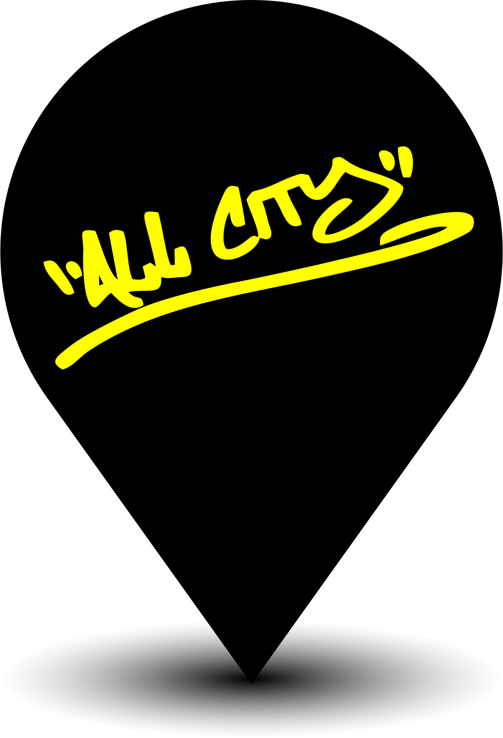 |  | 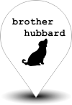 |  |  |  | 
 |  |  |  |  |  |  | 
Fig 10.1 Sample of custom marker pins
I mocked up almost every element of the site prior to attempting it in code.

When a user hovers over a marker pin, the name and address are shown akin to an ALT text in html.
When the user clicks on a marker pin a brief pop up 'bubble' is shown, controlled by the feature server this shows an external photograph of the shop and the name and address with a “...more” option.
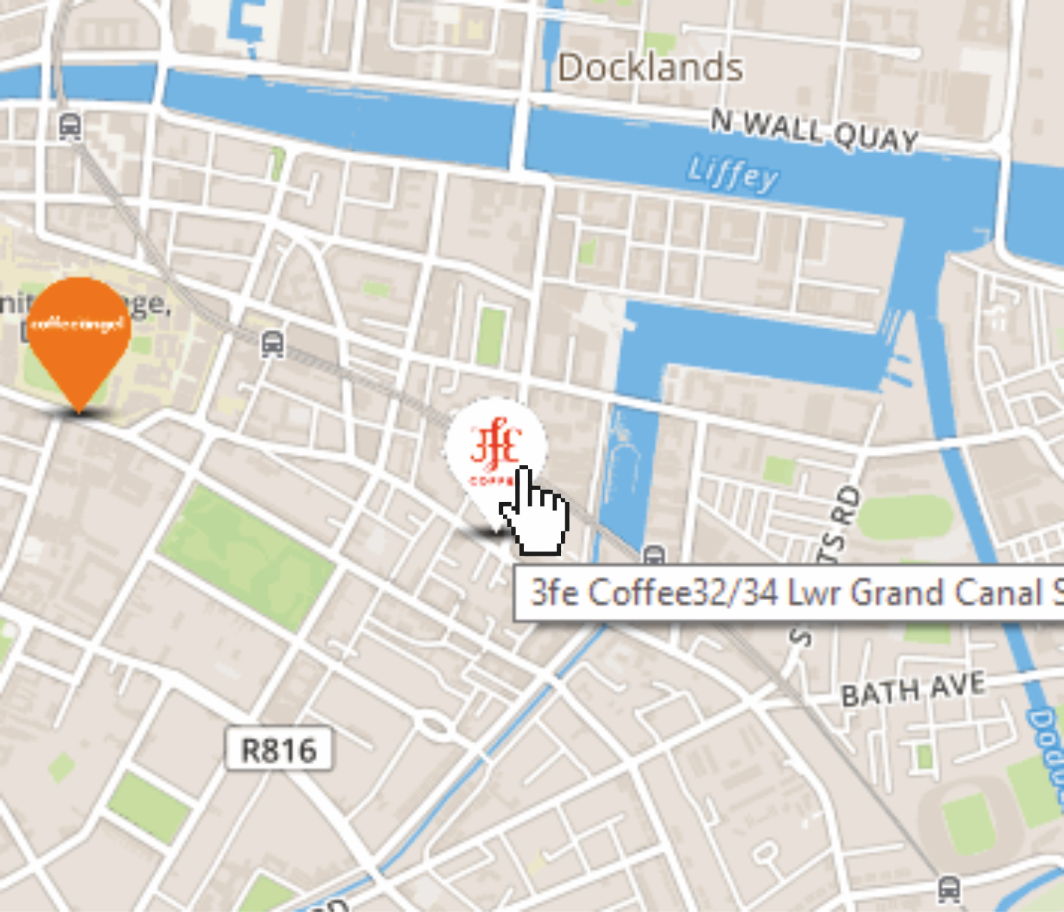  Mouse over action | 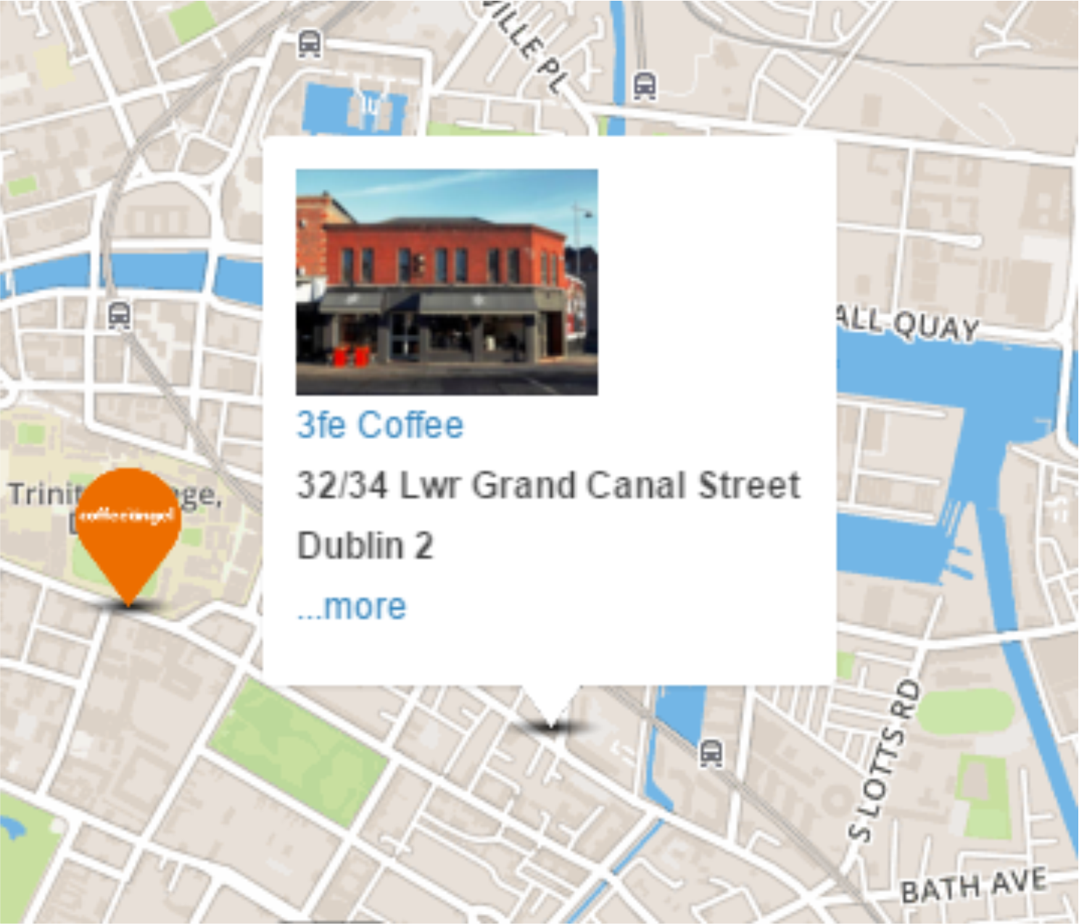  On click action
Fig 10.2
I had planned that when a user clicks on the ...more they would see information gleaned from the database for that shop in a formatted fashion similar to the mockup below.
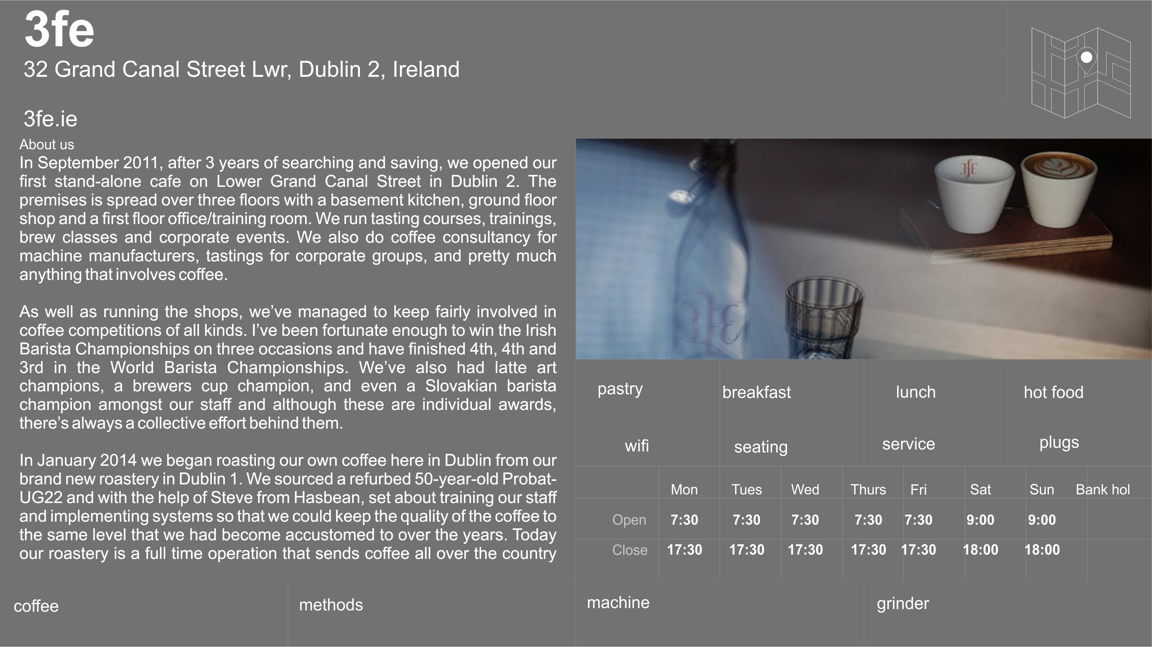
Fig 10.3
This is one example of many where my artistic sensibilities were forced to take a back seat to my coding ability. I could not make the above appear in any responsive manner apart from simply scaling the information for a smaller screen. I chose to revisit the design for this element
simplifying the information I wished to show and also keeping it in line with my technical abilities.

The design of the application has taken more than one turn during the course of development.
My initial design was a single page application with a map as the main navigation, hiding and showing menus using javascript. I developed an early html prototype for this but found the interface to be less than optimal with interaction not being very intuitive.
I went through three or four different hamburger menu versions before I found one that didn't look atrocious on both a large and small screen. But I still felt that I was restricting myself. The menu system was hidden off screen and the instructions on use themselves required a person to experimentally click to see if it did anything.
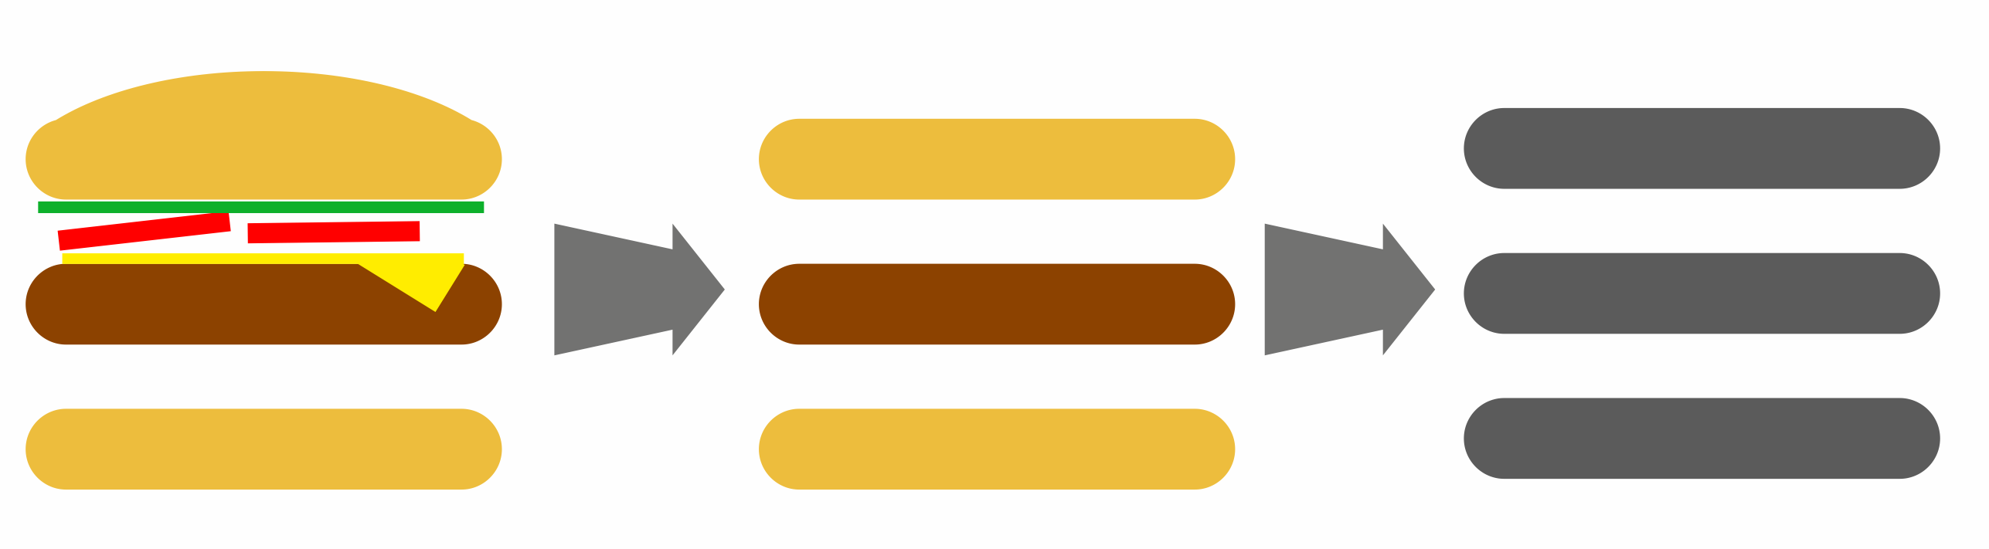

I then went back to the drawing board so to speak and started pen and paper and then on to graphics software, forgetting about my code for the time being.
I needed a starting point. I researched how others had decided on which path to follow when starting out with a new project. I stumbled upon an article by a much revered front end designer I follow on twitter named Luke Wroblewski (10.2 Wroblewski) I duly bought his book in July (10.3 Wroblewski2) and recognised some of the issues I was already coming up against. I found through a discount code delivered with the book another book by the same publisher on responsive design by Ethan Marcotte (10.4 Marcotte) which I duly bought and between reading and absorbing both books I procrastinated for quite a long time. I found these books to be both helpful and a hindrance. Providing me with the means to work around most problems but the client relationships and design lead development environment described was far beyond my abilities and expectations.
In one of Wroblewski's articles he has a suggestion that you carry out a study of existing websites with the client, having them rate their competition on a completely visceral reaction. Considering for the purposes of this project, I was both developer and client, I set about carrying out a study.

My visceral reaction study
I carried out a review of 10 map based location websites and marked them out of 10 for each of the following criteria:
- Appearance
- Ease of Use
- Functionality
- Similarity (to my planned design)
The above were less than scientific in nature, however I was basing my opinion on my initial 20 seconds or so interaction with each site which is more than most people allow before making a decision on a website.(Ginny Soskey, Hubspot, 2014)

This small study lead me to change direction of how the work flow on my site would operate. I found, that I preferred the sites which introduced the topic to be mapped first and also pointed out more than one piece of functionality which I had left out of my own application. For instance, I had neglected to include a restart button, which I find hugely helpful when dealing with mapping applications.
I also left out the idea of a modal / popup for further details of each shop. I had originally envisioned this as being a click through to another page but the modal is ubiquitous in todays internet and once I had incorporated it, even my children understood its use and had inherent knowledge on how to make it go away.
I then produced some mock-ups and screen shots and ran them by a number of people whose opinion I trusted. Once I had tweaked these to the point where I was ready to lock the details down, I began to flesh out the ideas in code.
This is where the design decisions made by pushing pixels around in a graphics editor sought to drive me insane.

Mobile First versus Responsive
I chose not to base my design on the mobile first rationale. After an initial trial run I soon found myself restricted in the usability of a site for desktop too. Whilst I do agree that mobile first ought to be the way an application such as mine should be developed, I felt that I did not possess the requisite skills to carry it out without extensive training.
There are a plethora of books and website alike for championing either one side or the other. I chose to borrow a little of both and built the main grid layout using twitter's bootstrap layout, but did not stick to this as a strict design decision. The fact that I wished to incorporate full screen maps automatically broke this and I ended up picking and choosing elements which delivered functionality I required. The end result is not what my software development colleagues would describe as being elegant or easily maintained, however time and experience constraints meant that choices were made and stuck to. The further I changed the site and developed solutions to issues I was experiencing, the less regard to bandwidth consumption of the resulting application was given. Given more time and a paying client, I feel I could improve both processing and network bandwidth requirements and improve the overall maintainability of the application.

The end result does, however, hold true more or less to my graphic screen mockups which I tried to use as my guide throughout. They are based on personal preference and taste.

